CST8202 – Windows Desktop Support

**Lab 3 – File Systems, Backup and Recovery**

**Purpose:** to navigate and manage files and folders, work with snapshots on VMware for documentation, understand how to create and manage Volumes, optimize and maintain file systems, including disk formatting, defragmentation, and error checking and backups. **Equipment/Resources:**

* College Approved BYOD Laptop
* Access To Brightspace
* Windows 11 Virtual Machine
* VMWare Workstation

**Objectives:**

Verify that you have a copy of the Windows 11 VMware.

**Section 1 – Working with snapshots:**

Snapshots are a good way to create restore points for your VM’s. Snapshots can be **Linear**, or **Hierarchical**.

* 1. If your Windows 11 VM is running; Power down before beginning this section.
  2. Click on VM -> Snapshot -> Snapshot manager. This is how the VM looks with no snapshots. All you see is the base VM and your current state. The “You are here” icon is your current state. If you take a snapshot now, you’ll save all the information for your current state to a snapshot.
  3. Click on “Take Snapshot” (Note the snapshot saving state in the bottom left corner of the VMware window.) You can use the VM while the snapshot is being made. For the sake of the lab, we’ll use a naming convention to help track the snapshots. Give the new snapshot the name “**Base**” and click okay.
  4. Click close.
  5. Examine the size of the snapshot in your Windows 11 Virtual Machine Directory. This can vary. You can see this by opening the directory where your VM’s are located. The size of the snapshots is directly related to how much memory is allocated to the VM.

The more memory, the larger the snapshot. If the VM is powered down, the snapshot will be much smaller.

* 1. Start your VM and place a text file on the VM’s desktop. Call it 1.1.txt.
  2. Take another snapshot by using the snapshot icon in the toolbar. Name it “1.1”. What difference do you notice about the snapshot process this time?
  3. 1.8While your snapshot is being created, rename the text file on the VM’s desktop to

1.2.txt. Create another snapshot called 1.2.

* 1. You should now see the chain of liner snapshots.

**NOTE**: You could revert to any of them at any time. You can also delete any or all at any time.

* 1. Right click on the “Base” snapshot and click “Go To Snapshot.” You should receive a warning; This simply means that you will lose any information from your current active state. 1.1 and 1.2 will remain intact. If you wished, you could make another snapshot to preserve your current state. Click yes and allow your current state to be lost.
  2. Once VMware restores the snapshot, you should see a new branch in snapshot manager. You have just made the 1st branch in a hierarchical snapshot. Your current state is now the beginning of a new branch, and any changes or snapshots will continue here. The 1st branch will remain unaffected.
  3. Close the snapshot manager

Add a Hard Drive to Your VM:

* 1. In VMware, select your virtual machine and then from the menu bar select VM > Settings. Click “Add…” to add an additional hard drive to your VM and Make certain you select:
     1. A SCSI hard disk
     2. It is a new virtual disk
     3. Set the size to 1 GB
  2. Ensure that you store your virtual machine disks in the same directory as the virtual machine.
  3. Make note of the filename of this virtual disk.

Create and Configure a New Volume:

* 1. Open Disk Management. Right-Click the Start button and select Disk Management from the list.
  2. You should be prompted to “Initialize Disk”; select MBR for the partition style and click OK to initialize. If you did not receive the prompt to Initialize, select Disk 2 and right click to Initialize Disk
  3. In the graphical display section, right-click Disk 2. From the menu, select New Simple Volume. Click Next to bypass the Welcome page. In the Specify Volume Size page, use the maximum size available. Click Next and Assign letter F: to this new volume: Use the following parameters:
     1. File system: NTFS
     2. Allocation unit size: Default (this determines the cluster size)
     3. Volume Label: Snapshots.
     4. Leave the Perform a quick format box selected and click Next. The information page appears. Verify all settings and click Finish.
  4. Open File Explorer. You should see Drive F: with almost 1GB of free capacity
  5. Take a snapshot. Label it 2.2.
  6. When the snapshot is completed; Right click on the “Base” snapshot and click “Go To Snapshot.”
  7. Examine the VM settings. Are there any missing devices? 1.23 Start your VM and once logged in open File Explorer

1.24 Drive F: should not be present.

Open an existing Disk:

1.24.1. In VMware, select your virtual machine and then from the menu bar select VM > Settings. Click “Add…” to add an additional hard drive to your VM and Make certain you select: SCSI. Click Next.

* 1. Select Use and Existing Virtual Disk and click Next
  2. Select Browse and navigate to the virtual machine disk file that you noted in step
  3. Click Finish and then OK.
  4. Open File Explorer. You should see your 1GB disk.
  5. What happened to the HDD within the VM when restoring to the Base Snapshot? **#1** Discuss how this behavior could be problematic for users **#2** or System Administrators **#3**

**NOTE: It** is a good idea to take a snapshot before each major section of your Assignments.

**Section 2 – Guest Isolation (Drag and Drop):**

You can use drag and drop / copy paste to share files between VMs and the host. You cannot use it to share folders between multiple VMs.

* + 1. Click VM → Settings → Options → Guest Isolation
    2. Check “Enable drag and drop” and/or “Enable copy and paste.” (I left them enabled when I created the VM)
    3. Click OK and verify by creating / dragging and dropping / copying and pasting some files between the host and VM.

**Section 3 – Storage Spaces:**

3.1 Create 2 identically sized 10GB disks and add them to your VM 3.2 Using storage spaces create a mirrored volume and assign the following

* + 1. Drive Letter M:
    2. Volume Label -SS
    3. File System: NTFS
  1. Verify that the disk exists using Disk Management **%4**

* 1. Copy the sample data “Gaia Cartographic” from Brightspace into your M: drive
  2. Simulate a disk failure by removing one (1) of the newly created 10GB disks from your VM.
  3. Examine File Explorer, Disk Management and Storage Spaces. What do you observe?

**#5** Are there other indicators that a disk is missing from the OS? **#6**

* 1. Simulate installing a replacement disk by creating another 10GB virtual Hard Disk
  2. Repair the mirrored disk array.
  3. Take a screenshot of your repaired storage space. **%7**

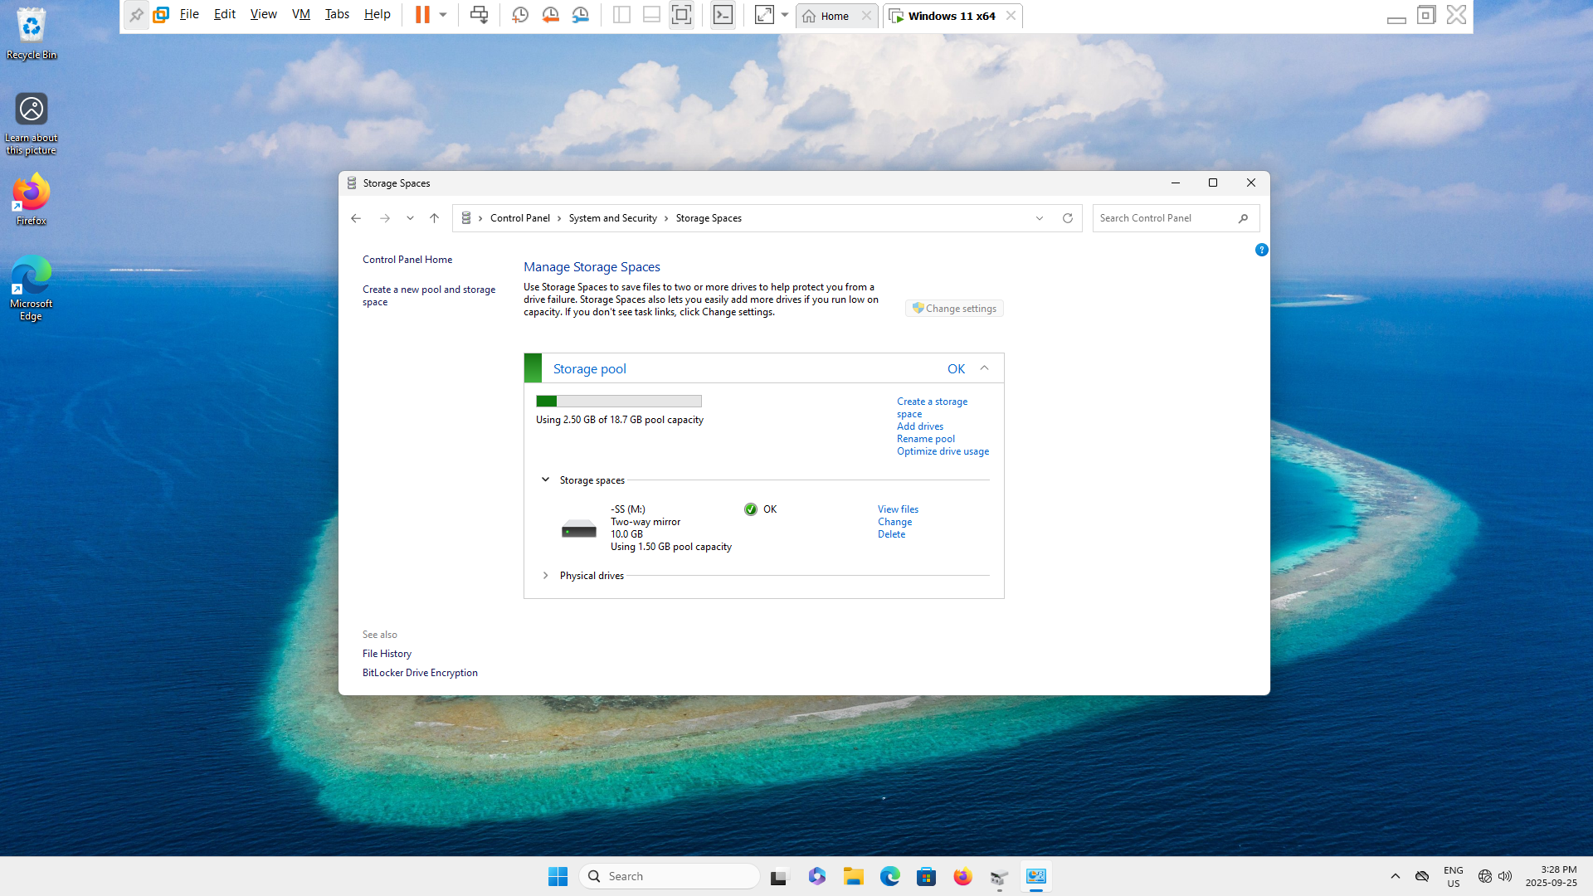

**Section 4 – Backup:**

* 1. Create a new disk and format a volume. This disk will be used for a File History back up. Record the parameters you used including capacity, cluster size, drive letter and file system. Include a brief rationale for these decisions. **#8** You may choose to support you answer with screenshots.
  2. In the root of your C: drive create a directory called “stuff to backup”.
  3. Copy the sample Data for Gaia Cartographic into the stuff to backup directory.
  4. Create a File History backup. Use the new volume you created in step 4.1 as a repository. Record all the settings you used and include them in your lab report. **#9**
  5. Ensure that the backup contains the data you wish to backup. Take a screenshot showing the recovery view which includes Gaia Cartographic. **%10**

* 1. Create a backup using Backup and Restore (Windows 7). Create a new disk if necessary. 4.7Why might it be important to understand the backup and recovery process for a deprecated operating system (consider BC/DR)? **#11**

**Section 5 – Host Backup:**

* 1. Create a host backup for your BYOD or other college workstation.
  2. Which directories did you decide to back up? Which did you intentionally exclude from your backup schema? **#12**
  3. What risks are you accepting with your host backup strategy? Consider aspects of backup and BC/DR best practices. Be sure to cite sources **#13**.

List of Deliverables

**#1** What happened to the HDD within the VM when restoring to the Base Snapshot? (Step 1.29)

**#2** Discuss how this behavior could be problematic for users (1.29)

**#3** Discuss how this behavior could be problematic for system Administrators (1.29)

**%4** Verify that the disk exists using Disk Management (3.3)

**#5** Examine File Explorer, Disk Management and Storage Spaces. What do you observe? (3.6)

**#6** Are there other indicators that a disk is missing from the OS? (3.6)

**%7** Take a screenshot of your repaired storage space. (3.9)

**#8**. Create a new disk and format a volume…Record the parameters you used (4.1)

**#9** Record all the settings you used and include them in your lab report (4.4)

**%10** Take a screenshot showing the recovery view which includes Gaia Cartographic (4.5)

**#11** Why might it be important to understand the backup and recovery process for a deprecated operating system (4.7)

**#12** Which directories did you decide to back up? Which did you intentionally exclude from your backup schema? (5.2)

**#13** What risks are you accepting with your host backup strategy? (5.3)

Submission Requirements

Include the screen shots and written answers that are indicated in the lab instructions

NOTE: **%** indicates a screen shot. **#** indicates a written answer. All lab submissions must meet the requirements, and follow the format, listed in the lab instructions posted on Brightspace.

Marks will be deducted for not following these instructions